The Balladeer
Monthly newsletter of Acoustic Routes, Wellington's folk music club

www.acousticroutes.org.nz

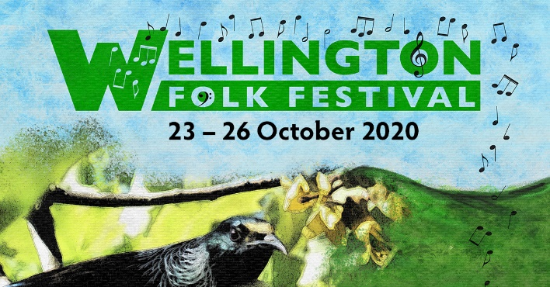

October 2020: In this issue
- Wellington Folk Festival, Brookfields Outdoor Education Centre, Wainuiomata, 23-26 October (No AR Monthly Concert because of Wellyfest)
- Open Mic, Plimmerton Boating Club, Thursday 8 October, 7 pm
- Open Mic at The Office, Newtown, Sunday 11 October, 5:15-8 pm
- Review, Parcel of Sage and Bob McNeill at Acoustic Routes, 24 September
- Obituary, Arthur Toms
- Balladeer Music Noticeboard
- Want to perform?
- About Acoustic Routes
- Acoustic Routes contacts
- Other regular folk events/contacts in the region

This newsletter can be printed out from a pdf located on the website http://acousticroutes.org.nz/news/the-balladeer/

Wellington Folk Festival, Brookfields Outdoor Education Centre, Wainuiomata, 23-26 October
Early bird prices available until Sunday 4 October at https://wellingtonfolkfest.simpletix.com/Event/57568/WellingtonFolkFestival2020
The return of most of New Zealand to Level 1 means Wellington Folk Festival is ready to rock at Labour Weekend at its regular venue – the beautiful Brookfield Outdoor Education Centre in Moore’s Valley, near Wainuiomata.

Possibly for the first time in its more than 50-year history, Wellyfest will be totally home-grown, due to the international Covid-19 travel restrictions, so the Festival features a top-class NZ guest list in its three-day programme.

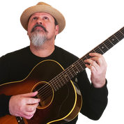 |  | 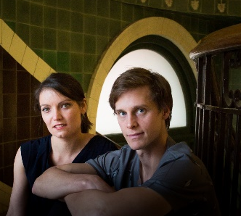
Darren Watson whose new album takes his original, contemporary blues into new ground. | Colette Rivers country-folk singer songwriter from the Wairarapa | Grawlixes - indie-folk band whose debut album ‘Set Free’ reached number 1 on the NZ weekly music album charts
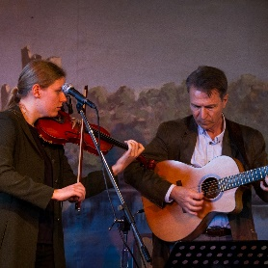 | 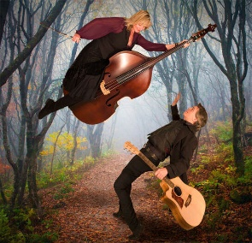 | 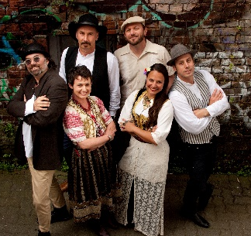
Entrada - Christchurch duo who play a unique blend of music for violin, guitar and mandolin. | Sadie and Jay - award-winning contemporary folk and roots duo now living in New Zealand. | Mehana - a Wellington-based band who draw inspiration from traditional music from the Balkan region.
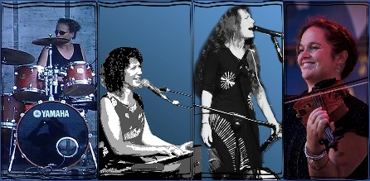 | 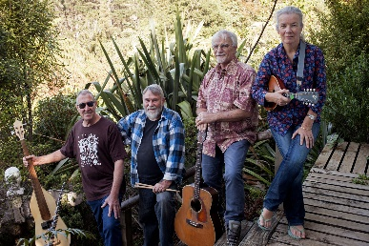 | 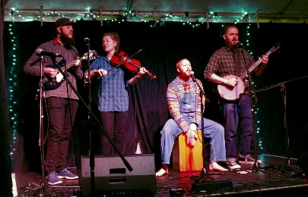
Raven Mavens Quartette with their originals, covers and standards bridging blues, alt-country and jazz. | Gumboot Tango from Taranaki, known for their unique take on Kiwi classics | Barry and the Crumpets - feet stomping old-time tunes, breakneck bluegrass and swampy blues.

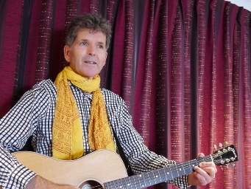 | 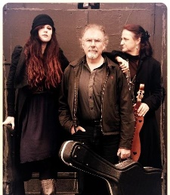 | 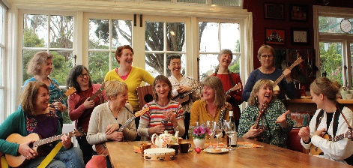
Alan Downes is going to release his 4th album with new tales from the rural heartland. | Moroney - a family band from Dunedin with an eclectic repertoire and warm harmonies. | The Flukes - Wellington ukulele women with an intriguing collection of songs and medleys.
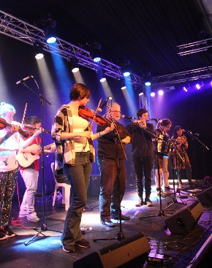
Participation is one of the key elements at Wellyfest. As well as concerts by the featured acts, the jam-packed programme includes plenty of opportunities for festival goers to perform and learn. There will be a huge range of music and dance workshops, blackboard concerts and singarounds, and of course the big Saturday night dance run by Vicfolk, followed by the late-night trad singing session.
Wellyfest President Gerard Hudson spoke to National Radio’s Bryan Crump recently on “Nights”. If you missed the interview, here’s the link:
https://www.rnz.co.nz/national/programmes/nights/audio/2018765507/look-ahead-to-wellington-folk-festival
For more info, check out the website the website: www.wellingtonfolkfestival.org.nz

Open Mic, Plimmerton Boating Club, 66 Moana Road, Plimmerton, Thursday 8 October, 7pm
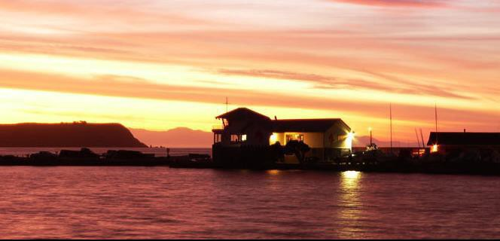
A highly popular monthly event in a lovely venue. Low cost drinks and food and a sound system.

Contact: Roy on 021 433-878.

Newtown Open Mic upstairs at The Office, Sunday 11 October, 5:15-8pm
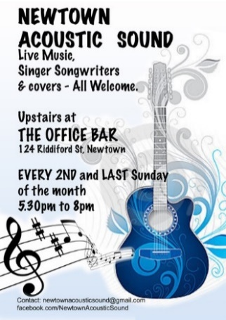
Open mic hosted Open mic hosted by Acoustic Routes and Newtown Acoustic Sound. It's the friendly little performance space, upstairs at The Office Bar in Riddiford Street. Bring two songs to sing, or a poem or two, some tunes or a story. In keeping with our names, we've gone totally acoustic, so we don't run a sound system.
Newtown Acoustic Sound has been going since 2015 and has just celebrated its 5th birthday. It aims to support musicians of all levels to play to a listening audience. We love original songwriters and give them an opportunity to craft their songs. We enjoy covers too and singing along.
NOTE: Due to Wellyfest happening, we won't be running a second open mic this month.
A BIG THANK YOU TO THE OFFICE BAR FOR THEIR CONTINUING SUPPORT
Contact: kevin.ikin@supermail.co.nz, or newtownacousticsound@gmail.com.

Review, Parcel of Sage and Bob McNeill at Acoustic Routes, 24 September
Despite the lockdown log jams, we have been able to enjoy some tremendous concerts in Wellington, at folk clubs, the Bluegrass Society and elsewhere. Acoustic Routes’ September concert at the dear old Roseneath School Hall was no exception.

Parcel of Sage, who opened the night for us, was an intriguing collation of three groups all familiar to local folk audiences. It encompassed the duo Sage – Sue Rose and Murray Kilpatrick; Sage Plus – that’s Sue and Murray with Susan Ellis; and Parcel – Sue and Murray with Marian and Barry Carter. That grand combo brought together a wonderful mixture of instruments and voices: guitars, bass and percussion mixed with the palette of Marian’s clarinet and saxophone and Susan’s violin, cello and banjo, and vocal harmonies. Parcel of Sage made the most of that, collectively and in smaller combinations, delivering one of the most satisfying sets you could hope to see at a concert. They wrapped up their multicourse menu with Sue and Murray’s lovely song about Pauatahanui, which has become a favourite dish.

Bob McNeill has experienced the disruptions of lockdowns and Covid restrictions more than many of us. They thwarted his efforts to launch his new album, Lost Stars, leading him to make the songs free on line as individual tracks. So, it was a real treat to see him on stage, relishing the opportunity to play to a live audience again after the enforced break.
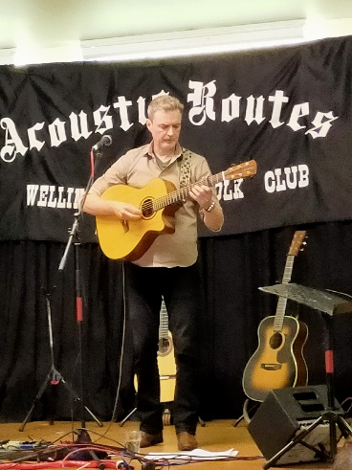

Bob’s set included songs from Lost Stars as well as recent albums recorded with Cape Breton fiddler fiddler Gillian Boucher, and Project Feijoa. The songs, inspired by people, places and events encountered in his travels, packed emotional power and atmosphere. Bob’s set was also highly versatile, featuring the different voices of three guitars and the sensitive use of looping pedals to layer vocals and instrumental backing.

So, a great night out, made even better by being able to catch up with people over a cuppa during the break. With Wellyfest on the way, Acoustic Routes won’t be running a concert in October, but I’m already looking forward to the next one in November.

Kevin Ikin.

Obituary, Arthur Toms
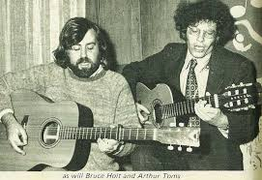
During big concerts like festival final concerts during the late 1960s and early 1970s, when a particular performer took the stage, there would be a loud hiss from the audience. It’s not that the audience disliked this performer. The audience was requesting the mellow drama Sweeny Todd. If the performer agreed to their suggestion, then part way through, an assembled bunch of whoever was around would run onto the stage waving arms and making lots of noise. The very well-known and highly respected performer was Arthur Toms who we fare welled last week.

Arthur was born in the UK and came out with the rest of his very musical family in his early teens. His Dad, Don Toms collaborated with Peter Cape helping Peter with the melodies for many of his songs, including ‘the Culler’s Lament.’ Don also set James K Baxter’s Poem ‘the Dry Cardrona’ to music and was indeed a very accomplished musician, singer and performer. Many of these skills and talents were passed on to Arthur and one of his younger brothers, Phil.

Arthur was a wonderful guitarist and accompanist. He never played flashy guitar, but all his arrangements were wonderfully crafted - very fitting and showing a thorough understanding of the music. he was also a very accomplished actor who appeared in numerous amateur theatre productions and he carried his acting ability over to his songs. He had a wonderful ability to project extremely graphic meanings in serious and humorous songs. I well remember the aforementioned Sweeny Todd mellow drama. ‘When Are We Gonna Get Married, My dear Little Buffalo Boy?’ which he played on banjo and vividly captured the conflicting gender agendas. ‘Sam Hall’ – Arthur’s version transported you very clearly to the situation of the person about to be hung. ‘John Smith AB’ built up a lasting image of life on an early sailing ship in the southern oceans. Arthur’s rendition of ‘Gut Board Blues’ milked the puns mercilessly. In short, he was a highly respected and accomplished musician, singer and performer who was also a champion of NZ songs.

I first met Arthur in the Wellington folk scene, at the Monde Marie and various clubs. He was one of the early computer programmers. Later he moved around NZ as a radio announcer for various local stations. He had passionate love of English cars, ie Rover V8, Jowet Javelin - oh and he did cross the channel and own a Peugeot.

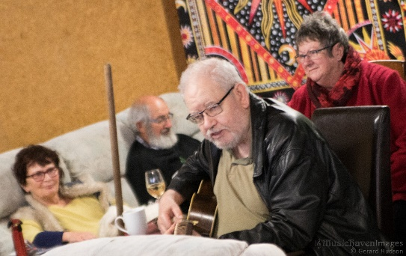
Arthur was always very generous with his help and support to younger and newer folkies. In the last few years, Arthur and his wife Christine settled in Tokomaru, where he became very involved with local politics and the local Church Parrish. He continued to play and sing. In fact, he and Christine briefly attended a small folky gathering earlier this year, where he delighted everybody with his version of ‘Chastity Belt’.

The NZ folk scene has just lost a very significant member. Thanks for everything Arthur. Very best wishes to Christine and all his family. RIP.

Murray Kilpatrick

Balladeer music noticeboard
Where you can advertise your music-related items—lessons, instruments, gigs, band members wanted, etc.
- Legacy Books for Sale
The Wellington publisher, Roger Steele, a long-time supporter of New Zealand folk music, is closing down his publishing business and has made stocks of music books available to Acoustic Routes. The club greatly appreciates Roger's support and generosity and we will be doing our best to find good homes for them.
- Neil Colquhoun’s revised edition of “Song of a Young Country”;
- “An Ordinary Joker – The Life and Songs of Peter Cape”;
- Phil Garland’s “Faces in the Firelight”; and
- “Gold’s a Wonderful Thing” - Charles Thatcher’s songs of the New Zealand diggings, edited by Robert Hoskins.
There are still a few for sale, so be in quick. $20 each, except for the smaller Charles Thatcher book which is $10. Two books for $30 or all four for $50. Proceeds to go towards funding the Joan Prior Young Performers Award.
They will be available at our events, or you can contact Acoustic Routes' secretary Kevin Ikin (kevin.ikin@supermail.co.nz) to place an order.
b) Marcus Turner CD: Live at Cardrona
This live recording will be welcomed by Marcus Turner's many admirers. Recorded in 2014 at the Cardrona Folk Festival, it is one of a handful of solo concerts that Marcus performed around this time which were so powerful and accomplished that those who were present felt privileged to be there. The album has 14 songs, twelve of which have not appeared on earlier recordings.
The CD costs $20 and you can get a copy from Linus Turner: linuscturner@gmail.com.


Want to perform?
The AR Committee would like to hear from you if you are interested in performing at our events, including support acts for our monthly concerts. Contact us at performers@acousticroutes.org.nz.

About Acoustic Routes
Acoustic Routes (Wellington Folk Centre Incorporated) is a club for people who enjoy playing and listening to folk and acoustic styles of music.
The fourth Thursday of the month generally features a concert, usually with a visiting artist and support acts from amongst our membership. Check the website or the Balladeer for updates about the venue.
Members get priority access to performance opportunities and can have input into the club's activities. To join, email treasurer@acousticroutes.org.nz.
Acoustic Routes publishes this newsletter (The Balladeer) at the start of every month, and also an acoustic gig guide for the Wellington region (Acoustic Routes update). You can subscribe online, or contact publicity@acousticroutes.org.nz.

Acoustic Routes contacts
President: Ruth Birnie president @acousticroutes.org
mailto:ruthlbirnie@gmail.com
Correspondence: Kevin Ikin secretary@acousticroutes.org.nz Treasurer/Membership: Karen Munro treasurer@acousticroutes.org.nz
<karenguitarist@hotmail.com>
Balladeer: Philippa Boy balladeer@acousticroutes.org.nz gurdyphilippa@gmail.com
Acoustic Routes update email: Kevin Ikin secretary@acousticroutes.org.nz
Performance opportunities: performers@acousticroutes.org.nz
mailto:ruthlbirnie@gmail.com
Postal address: PO Box 27-191 Marion Square, Wellington, New Zealand.
Website: www.acousticroutes.org.nz

Other regular folk events/contacts in the region

Trad Singing Session with Dave Barnes hosting

When: 2nd Monday of the month, from about 6.45pm

Where Upstairs at the Sprig and Fern, Thorndon. This session celebrates unaccompanied singing in traditional style. Fine beer and food to be had at the bar.

Contact: Dave Barnes david.barnes@xtra.co.nz
Ceol Alba Scottish Music Club
When: 4th Friday of the month, 7.30 - 9.30pm. A club for playing and/or listening to (mostly) traditional Scottish music. Sheet music supplied or downloadable
Where: Lower Hutt.
Cost: $5 per night
Contact: Lynne Scott, 04 565 0164 lynne@scott.gen.nz

Kapiti Live Music Club
When: 2nd Wednesday of the month, an acoustic social evening for listening and/or singing and playing, from 7:30pm
Where: Paul and Kimbra's; 3 Jade Lane, Paraparaumu. Off the east end Mazengarb Road as it changes name and turns toward Kapiti Road.
Contact: enquiry@klmc.org.nz anhttp://www.klmc.org.nz
Kelburn Pub Live Music
When: Live music every Sunday 3pm-5 pm
Sunday Roots on the first Sunday of each Month, 4-7pm. Hosted by Pip Payne and featuring a different guest artist each month. Details: 'Sunday roots' on Facebook. Contact the Pub if you are interested in performing.

Levin Folk Music Club
When: 2nd Friday of month, 7.30 pm, blackboard concert plus guest artist.
Entry: Members $5, Non-Members $10, Children $3 (includes supper)
Club Night: 4th Friday of month, 7.30 pm $2 Koha.
Where: Horowhenua Scottish Society Hall, cnr Bartholomew Rd and Middlesex St.
Bookings: Bookings: Dale Webb dalewebb143@gmail.com
Website: www.levin-folk-music-club.org.nz

Mainly Acoustic Music Club
When: (Mostly) every 2nd Tuesday of the month, 7.30pm
Where: Mayfair Cafe, 116 Main Street, Upper Hutt
Contact: Mary Khalil 021 02314505 mary.khalil@xtra.co.nz Club committee email: info@mainlyacoustic.co.nz
Website: http://mainlyacoustic.co.nz/coming-attractions/

Morris dancing: Dave Barnes http://www.morrisdancing.org.nz/
Pukerua Bay Folk Club
When: 1st Thursday of the month, 8pm
Where: 9 Donlin Rd, Pukerua Bay
Contact: Murray or Julie Kilpatrick, (04) 239 9951, musicianmurray@gmail.com

Wellington Bluegrass Society
When: 3rd Friday of the month, 8pm
Where: 54 Richmond Street, Petone
Contact: Andrew Bicknell, (04) 477 0069, bluegrass@xtra.co.nz
http:// wellingtonbluegrass.net.nz/

Wellington Scottish Fiddle Club
When: Varies, but mostly monthly around the first Sunday
Where: Depends on who is hosting it this time! A club for learning tunes in the traditional "by ear" style, it welcomes fiddlers of all levels.
Cost: Mostly free
Contact: Iain Matcham 04 568 8635, email iain@jumbletree.com

